**VISVESVARAYA TECHNOLOGICAL UNIVERSITY**

“Jnana Sangama”, Belagavi – 590018



A MINI PROJECT REPORT ON

CARGO MANAGEMENT SYSTEM

Subject: Data Base Management System

BACHELOR OF ENGINEERING IN

COMPUTER SCIENCE AND ENGNEERING

Submitted By,

N R ARUN KUMAR(4AI18CS009)

PRAJWAL S MOUDGALYA(4AI18CS073)

##### 

##### **Under the guidance of**

###### **Mrs. Priyanka N B.E., M.Tech.**

**Assistant Professor, Dept of CS&E,AIT,Chikkamagaluru.**



# DEPARTMENT OF COMPUTER SCIENCE AND ENGINEERINGADICHUNCHANAGIRI INSTITUTE OF TECHNOLOGY

**Affiliated to VTU, Belagavi and Approved by AICTE, New DelhiChikkamagaluru _ 577102, Karnataka, India.**

**2020-2021**

**ADICHUNCHANAGIRI INSTITUTE OF TECHNOLOGY**

(Affiliated to VTU, Belagavi and Approved by AICTE, New Delhi)

Chikkamagaluru- 577 102, Karnataka, India.

**Department of Computer Science and Engineering**

**CERTIFICATE**

This is to certify that the project work entitled “CARGO MANAGEMENT DATABASE SYSTEM” is a bonafide work carried out by N R ARUN KUMAR (4AI18CS009), PRAJWAL S MOUDGALYA (4AI18CS073) in partial fulfillment for the DBMS Laboratory with mini project (18CSL58) course of 5th semester Bachelor of Engineering in Computer Science and Engineering of the Visvesvaraya Technological University, Belagavi during the academic year 2020-21. It is certified that all corrections and suggestions indicated for Internal Assessment have been incorporated in the report deposited in the department library. The mini project report has been approved as it satisfies the academic requirements in respect of Mini Project Work prescribed for the said degree.

###### Mrs. Priyanka N B.E., M.Tech.

Assistant Professor,

Dept of CS&E,AIT,

Chikkamagaluru.

###### Dr. Pushpa Ravikumar B.E., M.Tech.,Ph.D.

Professor & Head,

Dept of CS&E,AIT,

Chikkamagaluru.

**Signature of the Guide Signature of the HOD**

**Name of Examiners Signature of Examiners with date**

**1.**

**2.**

**ABSTRACT**

In order to transport goods or products from one territory to other, cargo system is important. It is fast, easy and reliable commercial means for transportation of goods and industrial products from one part of globe to another. This proposed project is simply an attempt to generate an application to automate different management activities in cargo business.

**Existing System:**

The traditional cargo management system is completely manual and hence, tedious and much time consuming. There is a high chance of losing and delivering the items to wrong recipients due to misplacement of a single paper. So, a computerized and online management system is an ultimate solution to such problems in Cargo-related systems.

**Proposed System:**

The proposed cargo management system application performs multi-task in effective management of cargo companies. The major aim of the generated application from the project is to reduce the manual work and provide fast, comfortable, reliable and effective service. The software can record data in the database, display billing details, inquire modules, and many more.

As the implementation of software in cargo agencies reduces the number of workers and paper works, it ultimately minimizes the overall expenditure of the company. Moreover, it helps the company in its promotion though web technology.

**ACKNOWLEDGEMENTS**

We express our humble Pranamas to his holiness **Parama Poojya Jagadguru Padmabushana Sri Sri Sri Dr. Balagangadharanatha MahaSwamiji** and **Parama Poojya Jagadguru** **Sri** **Sri Sri Dr. Nirmalanandanatha MahaSwamiji** and also to **Sri Sri Gunanatha Swamiji** Sringeri Branch Chikkamagaluru who have showered their blessings on us for framing our career successfully.

We are deeply indebted to our honorable Principal **Dr. C. T. JAYADEV** for creating the right kind of care.

We express our deepest gratitude to **Dr. Pushpa Ravikumar**, Professor & Head, Department of Computer Science & Engineering, AIT, Chikkamagaluru for her valuable guidance, suggestions and constant encouragement without which success of our project work would have been difficult.

We are thankful to our guide **Mrs. Priyanka N**, Assistant Professor, Department of Computer Science & Engineering, AIT, Chikkamagaluru for her inspiration and lively correspondence right from the beginning of our project work till its completion.

We would like to thank our beloved parents for their support, encouragement and blessings.

And last but not the least, we would be very pleased to express our heartfelt thanks to all teaching and non-teaching staff of CS&E department and our friends who have rendered their help, motivation and support.

**Table of Contents**

Abstract 3

Acknowledgements 4

Table of Content 5

List of Figures 6

List of Tables 7

**Chapters Page No.**

**1. INTRODUCTION**

1.1 Introduction to Cargo Management database system **8**

**2. SOFTWARE REQUIREMENTS SPECIFICATION 10**

2.1 Overview 10

2.2 Specific Requirements 11

2.2.1 Software Requirements 11 2.2.2 Hardware Requirements 11

**3.** **CARGO MANAGEMENT DATABASE DESIGN 13**

3.1 E-R Diagram 13

3.2 Relational Schema 14

**4. IMPLEMENTATIONS 15**

4.1 RDBMS Tables and their Description 15

4.2 MySQL Query 19

4.3 Connecting to MySQL using PHP code 21

**5. RESULTS 22**

**6. CONCLUSION AND FUTURE ENHANCEMENT 27**

6.1 Conclusion 27

6.2 Future Enhancement 27

**REFERENCES 28**

**List of Figures**

**Figure No. Figure Name Page No.**

Figure 3.1: E-R diagram of Cargo database system 13

Figure 3.2: Cargo Relational Schema 14

Figure 4.1:list of tables in Cargo database management system 15

Figure 4.2: admin login details 15

Figure 4.3: sender details 16

Figure 4.4: receiver details 16

Figure 4.5: cargo details 17

Figure 4.6: Payment details 18

Figure 4.2.1: Query Retrieve the details of the admin to get login 19

Figure 4.2.2: Query to Insert the receiver details 19

Figure 4.2.3:delete information of sender”. 20

Figure 4.2.4: Query to update the login details of admin 20

Figure 4.2.4: Query to ALTER the table 20

**List of Tables**

**Table No. Table Name Page No.**

Table 1: **Admin_login: 15**

Table 2: **Sender 16**

Table 3: **receiver 16**

Table 4: **cargo_details 17**

Table 5: **Payment: 18**

**CHAPTER 1**

**INTRODUCTION**

**1.1 Introduction to Cargo Management database system**

This Cargo Management System Project will have different modules. The login section will have login facility for the admin and for the user who will operate this system. While taking orders from its customers, it will take all the details of its customers who is placing the orders and all the details for the recipient such as its address, name, mobile number. During billing process system will generate a tracking id for their products. Through this tracking id, customers or its recipient will able to track their products from any location using internet. It will provide status of the product after placing orders within 1 minute.

This Cargo Management System Project will provide information recipient with following details:- where the current consignment is, till when it will reached its final destination, if any delay then reason of the delay, the route of current consignment, date of placing consignment, final date to reach its destination.

When the consignment will visit to the city office of destination, a message will be send to the recipient with delivery status confirmation. Then after getting this message its recipient can take its parcels by using their Track Id. When its recipient will receive their parcels, then this Track Id will be deleted automatically from the system database after 1 week by sending final confirmation message to its recipient mobile number which will include information of Track Id, date of receiving and time along with greeting message for providing further service in future.

In modern age, as time increase, needs & requirements of the person are also increased. They want more facility & try to do their task quickly & within time. But they can not get all the things at nearest market or area, so they have to import the things from any place in the world. Within the country, the things can be imported through post service. But it consumes the time & sometimes problem of damage or missing occur. Where as in the international market, the one way is shipping. But it also requires more time. - (2) - Cargo Management System The cargo service is one of the solutions of these problems. It is used to send some things to any person in the world within time. The cargo company has number of branches, which are spread over the country . So that when person wants to send things then he has to contact at nearest cargo service branch. The cargo company creates the schedule & gives internal/external services. The cargo service work as destination office or source office. The source office branch receives the order means consignments & sends it to the destination cargo branch. The company has certain rules according to the weight. Using the courier service person can easily send his/her parcel to other person in the particular destination within the time. Now days, 50% of companies of our Country uses the services of various cargo company.

**Chapter 2**

**SOFTWARE AND HARDWARE SPECIFICATION**

The Cargo Management database makes use of various software and hardware for its design. It makes use of present technologies and tools for making it easier for better performance and also to improve the efficiency of the overall system.

**2.1 OVERVIEW**

People when transfer their products using any cargo service wants to know whether their product has been shifted to their right place or not, if not then by what time it will be shifted and where it is now. Taking all this information manually is very difficult and time taking process. To handle all these activities include various processes and paper work from the management side also

To gain maximum business region, customer demands good service. So to make more profit and gain maximum business region, their administration must also have a system to tackle all these problems on time. Its administration can take immediate orders and provide a receipt which will include all the details of the products along with appropriate price to their customers.

**2.2 SPECIFIC REQUIREMENT**

Any system design requires tools and technologies for its easy and efficient performance. Below are the specification of software and hardware that has been used for the design and implementation of the Cargo Management database system.

**2.2.1 SOFTWARE REQUIREMENTS**

Software is required to store the data about the Cargo management and MySQL is used to serve this purpose. The details are divided into 5 tables and stored. They are mapped so that the data can be easy retrieved through connectivity. The queries, procedure and the triggers are used for performing various actions on the database.

For the front end ADOBE DREAM VIEWER 2020 is used which helps to create a web pages as per the requirement of the project. The front end is connected to the database with the help of the HTML and CSS. The queries are written as per the buttons and links created in the front end and this result in easy retrieval of the data from the database system.

* Operating System : Windows 10
* Front End : ADOBE DREAM VIEWER 2020
* Programming Language : HTML & CSS
* Connecting language : PHP
* Back end :My SQL

**2.2.2 HARDWARE REQUIREMENTS**

Similar to that of software requirements there are some hardware requirements that is essential for the operation of the Cargo Management database system. A processor of core i3 is used for this system development. Memory is needed for storage in the back end as well as for the execution at the front end.

* Processor :i5 processor or higher version
* Ram :1 GB or more
* Hard Disk Free Space :5GB

**CHAPTER 3**

**CARGO MANAGEMENT DATABASE DESIGN**

**3.1 E-R Diagram:**

An **entity-relationship diagram** (**ERD**) is a data modelling technique that graphically illustrates an information system's entities and the relationships between those entities.

An entity-relationship model (ER model) describes inter-related things of interest in a specific domain of knowledge. An ER model is composed of entity types (which classify the things of interest) and specifies relationships that can exist between instances of those entity types.

An **entity-relationship diagram (ERD)** is crucial to creating a good database design. It is used as a high-level logical data model, which is useful in developing a conceptual design for databases. An entity is a real-world item or concept that exists on its own. Entities are equivalent to database tables in a relational database, with each row of the table representing an instance of that entity.

An attribute of an entity is a particular property that describes the entity.A relationship is the association that describes the interaction between entities. Cardinality, in the context of ERD, is the number of instances of one entity that can, or must, be associated with each instance of another entity. In general, there may be one-to-one, one-to-many, or many-to-many relationships.

Figure 3.1 shows the sample ER diagram which consists of five entities Admin, sender, reciever, cargo_details, and Payment.

sender

Admin

Manage

has

reciever

Payment

Cargo_details

**Figure 3.1: Cargo Management Entity Relationship Diagram.**

**Relational Schema:**

The relational schema gives the relation of one entity with another as well as the information about the key constraints. The below figure is sample relational schema diagram in which the attributes that are underlined are the primary key and the arrow line is used to represent the mapping.

The figure 3.2 shows the schema diagram for the Tourism Management database system. As, mentioned previously the database system consists of 5 entities and 2 relations. The names that are placed inside the rectangular boxes specify the attributes. The line with arrows is indicating the mapping between the relations.

**ADMIN_LOGIN**

username

password

Admin_id

**CARGO_DETAILS**

**\**

type

cid

width

length

quantity

height

weight

**SENDER**

**\**

Delivery_status

sid

sstate

scity

smno

semail

sadr

sname

**RECIEVER**

**\**

rid

rstate

rcity

rmno

remail

radr

rname

**PAYMENT**

**\**

amount

Payment_id

Expiry_date

name

Card_no

cvv

Payment_mode

**Chapter 4**

**IMPLEMENTATION**

**4.1 RDBMS tables and their description**

Below table shows the list of tables used in implementation of the Cargo database management system.

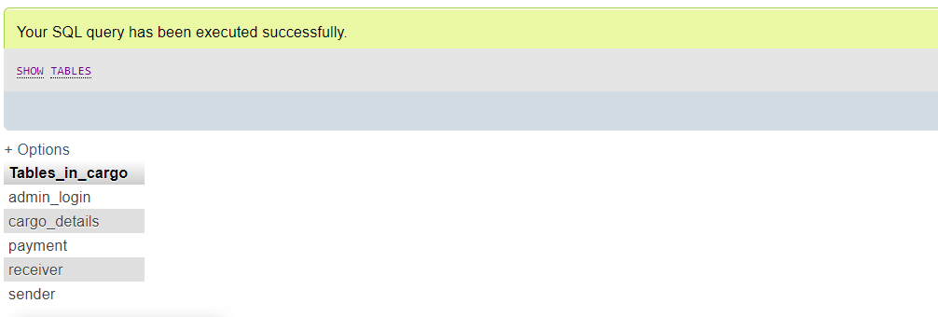

figure 4.1:list of tables in Cargo database management system

**4.1.1 Admin_login:**

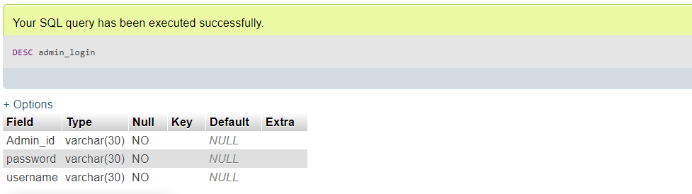

Figure 4.2: admin login details

Table1 is used to add all the information’s about the admin.

**4.1.2 Sender:**

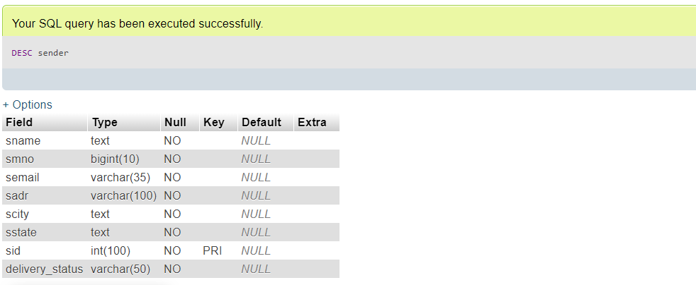

Figure 4.3: sender details

Table2 is used to show the details about sender as shown above.

**4.1.3 reciever:**

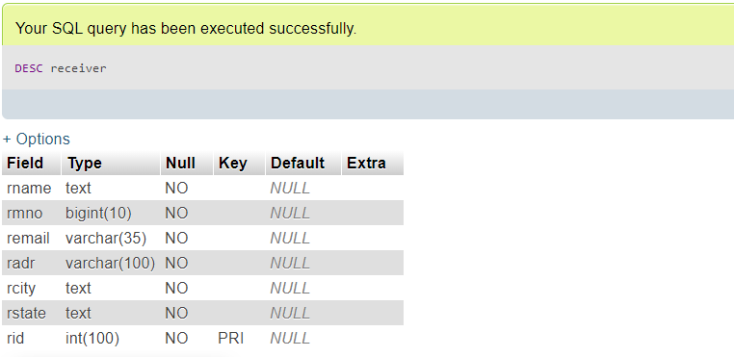

Figure 4.4: receiver details

Table3 contains the receiver details .

**4.1.4 cargo_details:**

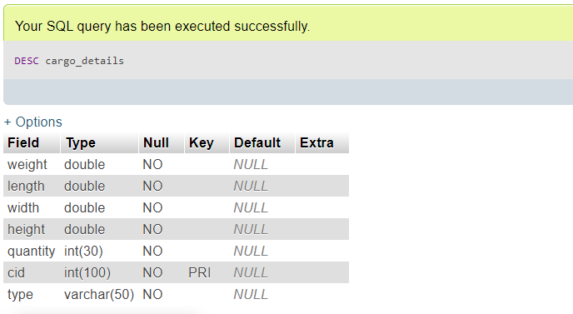

Figure 4.5: cargo details

Table4 contains the cargo details

**4.1.5 Payment:**

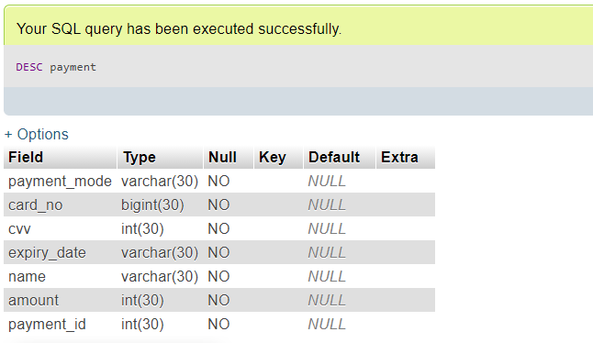

Figure 4.6: Payment details

Table5 is used to provide the details about the payment by user. It contains a card_no (unique attribute),pay_mode, cvv_no, expiry_date, payment_id (it is foreign key attribute referred by table user) .

**4.2 MySQL Query**

i) SELECT command is used to retrieve the data from admin

SELECT * FROM `admin_login` WHERE 1

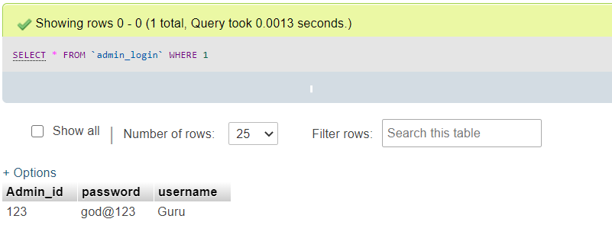

Figure 4.2.1: Query Retrieve the details of the admin to get login

ii) Insert the receiver details.

INSERT INTO `receiver`(`rname`, `rmno`, `remail`, `radr`, `rcity`, `rstate`, `rid`) VALUES ([value-1],[value-2],[value-3],[value-4],[value-5],[value-6],[value-7])

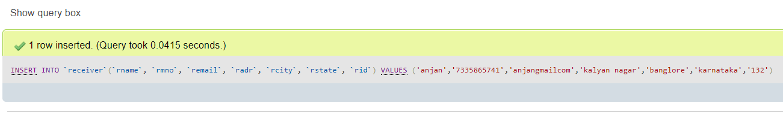 Figure 4.2.2: Query to Insert the receiver details.

iii) DELETE the sender details.

DELETE FROM `sender` WHERE ‘sid’= (id)

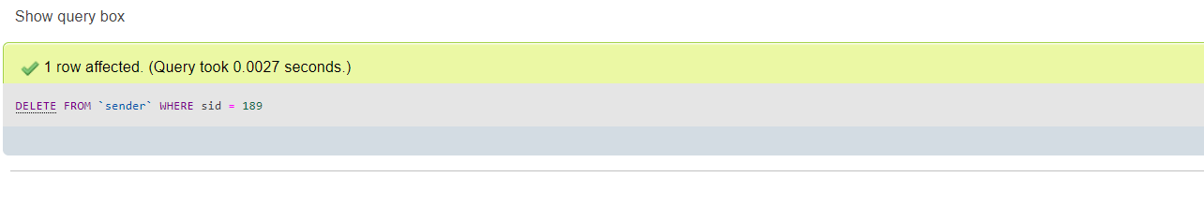

Figure 4.2.3:delete information of sender”.

iv) UPDATE the Admin login details

UPDATE `admin_login` SET `Admin_id`=[value-1],`password`=[value-2],`username`=[value-3] WHERE 1

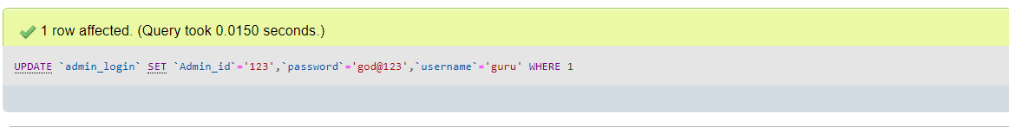

Figure 4.2.4: Query to update the login details of admin.

V)ALTER TABLE COMMAND

ALTER TABLE admin_login ADD grouping varchar(30) NOT NULL

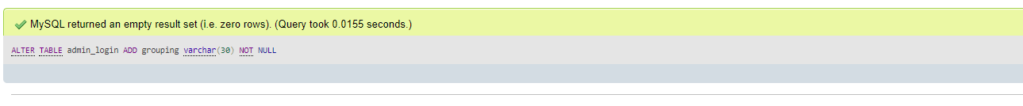

Figure 4.2.4: Query to ALTER the table

**4.3 Connecting to MySQL using PHP code**

<?php

$server="localhost";

$user="root";

$pwd="";

$db="cargo";

$conn=mysqli_connect($server,$user,$pwd,$db);

if(!$conn){

die('connection unsuccessfull'. mysqli_error());

}

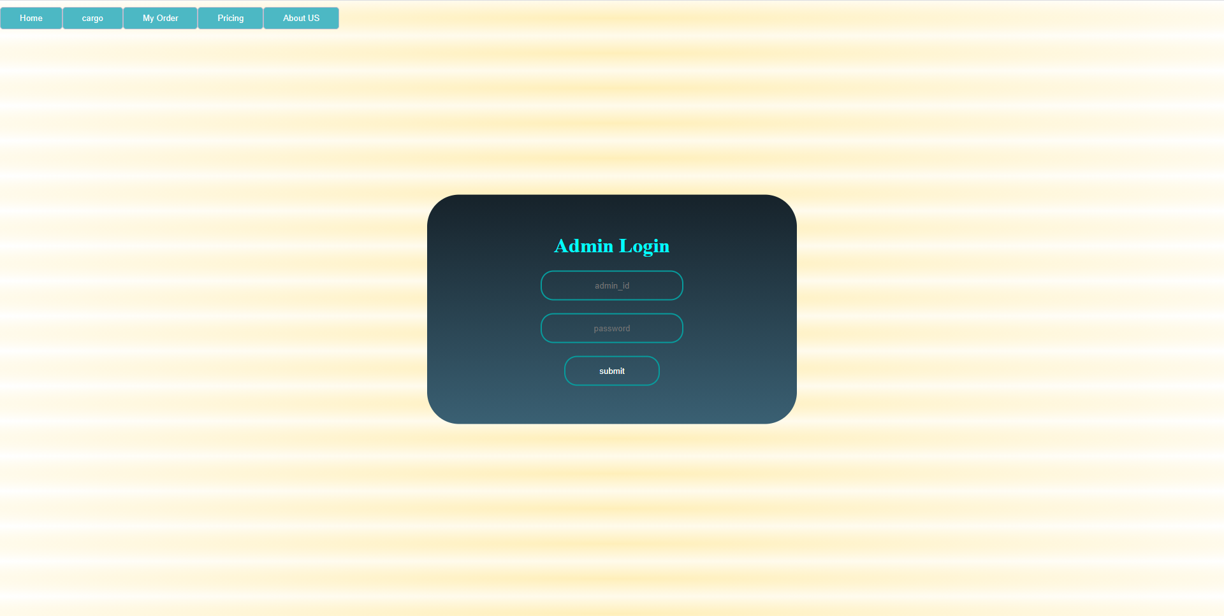

**CHAPTER 5**

**RESULTS**

**5.1 OUTPUT 1**

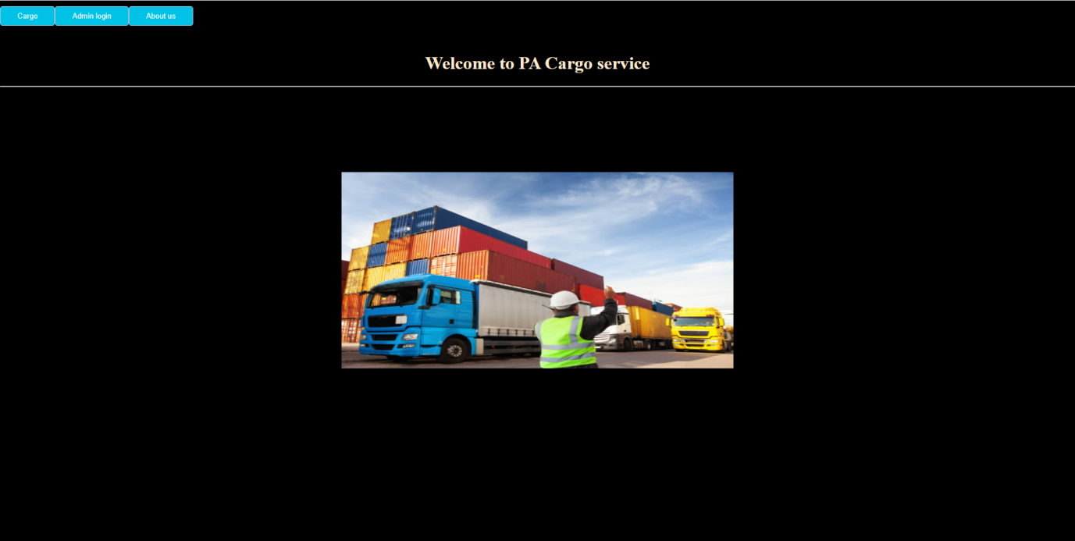

**Snapshot 5.1: Snapshot displays loHomefor the Cargo management system.**

**5.2 OUTPUT 2**



**Snapshot 5.2: This Snapshot displays the admin login page**

**5.3 OUTPUT 3**

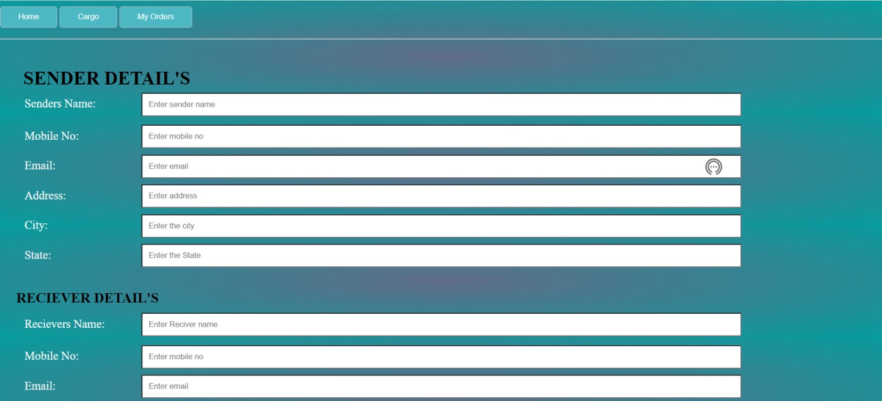

**Snapshot 5.3 : Snapshot of cargo table in Cargo Management system.**

**5.4 OUTPUT 4**

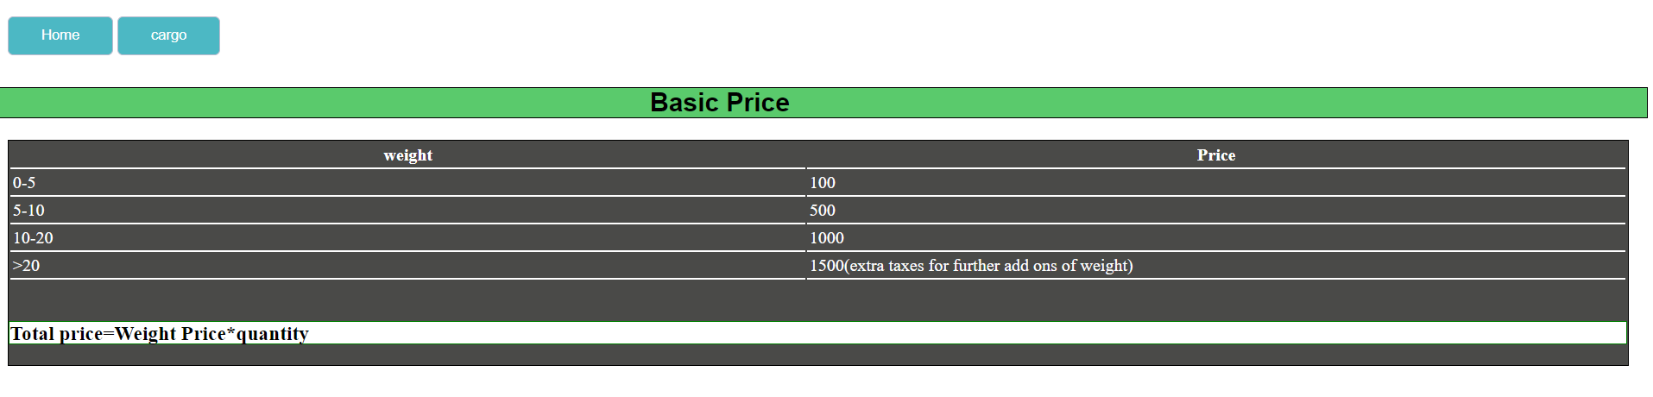

**Snapshot 5.4 : Snapshot of Basic price details.**

**5.5 OUTPUT 5**

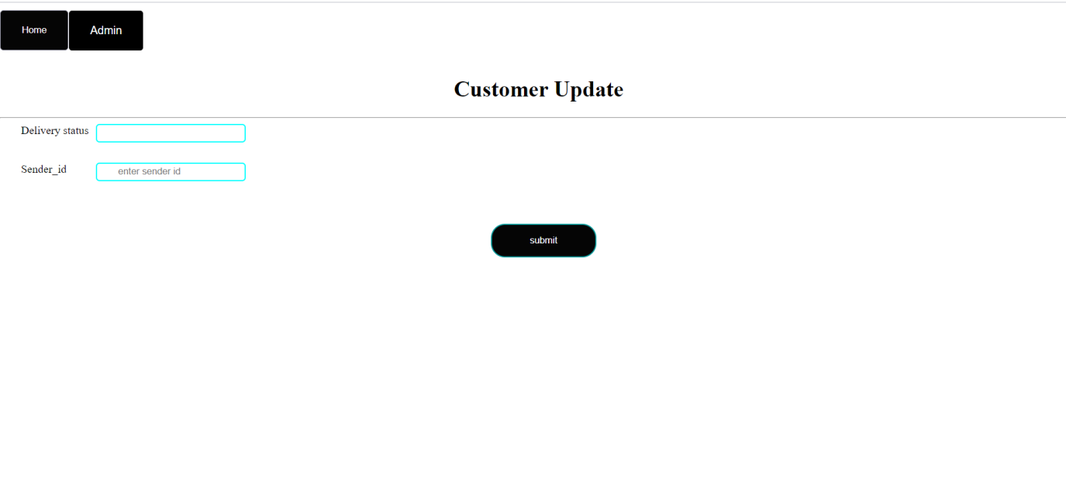

**Snapshot 5.5: Snapshot of admin update details table.**

**5.6 OUTPUT 6**

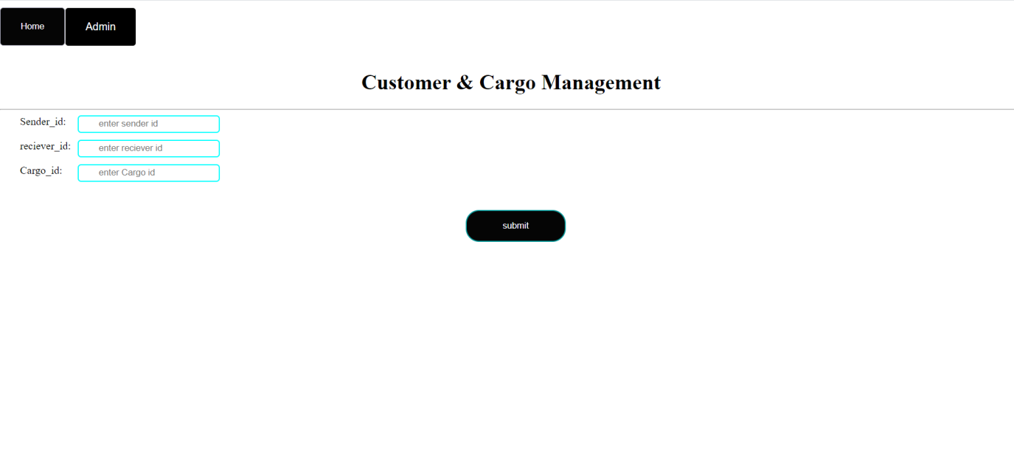

**Snapshot 5.6: Snapshot of Deletion of customer details.**

**5.7 OUTPUT 7**

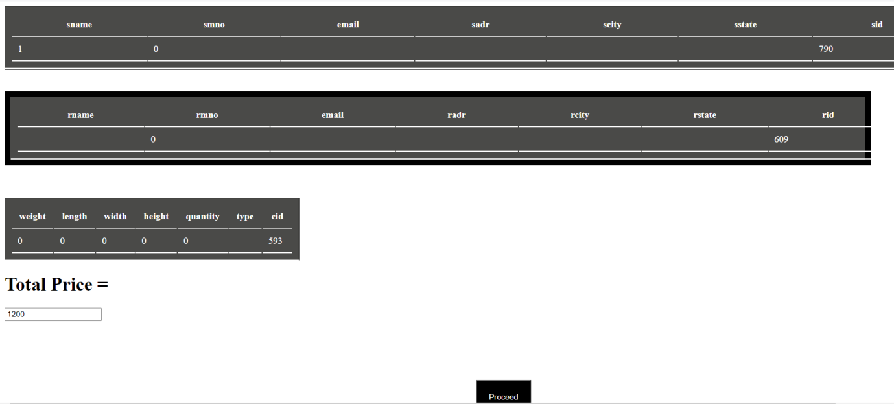

**Snapshot 5.7: Snapshot of customer retrieved details page.**

**5.8 OUTPUT 8**

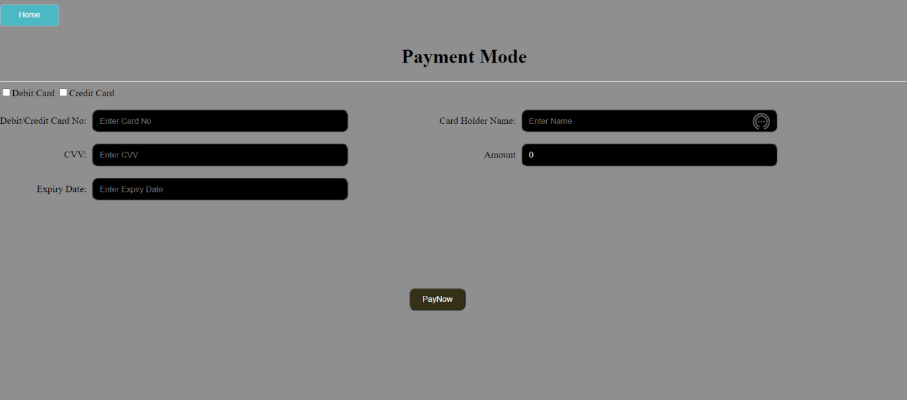

**Snapshot 5.8 : Snapshot of Payment page**

**5.9 OUTPUT 9**

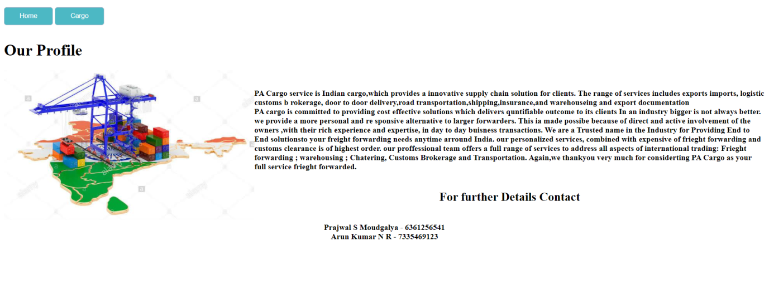

**Snapshot 5.9: Snapshot of About us page**

**5.10 OUTPUT 10**



**Snapshot 5.10: Snapshot of my orders page.**

**Chapter 6**

**CONCLUSION AND FUTURE ENHANCEMENT**

**6.1 Conclusion**

This project gave us the idea about, how large data are stored inside a database and organised so that it can be retrieved easily and in a more efficient way. It also helped us in learning to create application usingPHPcode and connecting the back end with the front end using the PHP code, so that any actions that are performed in the front end are reflected in the back end and also any modifications made at the back end can also be seen in the front end. It also gave us complete idea about how the queries retrieve data from multiple tables and the working of structured procedure and the triggers. This project is used to maintain the Cargo Management System efficiently.

**6.2 Future enhancement**

In future this system can be extended to the desired level so that it can adapt to the changing technology and enhance its performance. The latest data can also be included into the database so that the future retrieval keeps all the necessary data that has been updated. The system can be provided with any sort of queries to perform the required actions with the help of the schema. It also performs some computations that can be altered or modified as per the latest requirements.

**REFERENCES**

1. Fundamentals of Database Systems, Ramez Elmasri and Shamkant B. Navathe, 7th Edition, 2017,

Pearson.

2. Database management systems, Ramakrishnan, and Gehrke, 3rd Edition, 2014, McGraw Hill

3. Silberschatz Korth and Sudharshan, Database System Concepts, 6th Edition, Mc-GrawHill, 2013.

4. Coronel, Morris, and Rob, Database Principles Fundamentals of Design, Implementation and Management, Cengage Learning 2012